Jacob Perry

3/12/2024

2-3 Milestone One: Project Proposal

I spent a lot of time trying to find the perfect image for me to recreate in 3D from any of my favorite video games. Every time I found something that I thought may work, I found one reason or another that I did not see it fit for this project. I ended up just collecting some household items and laying them out on my computer desk to create an image to base my project on.

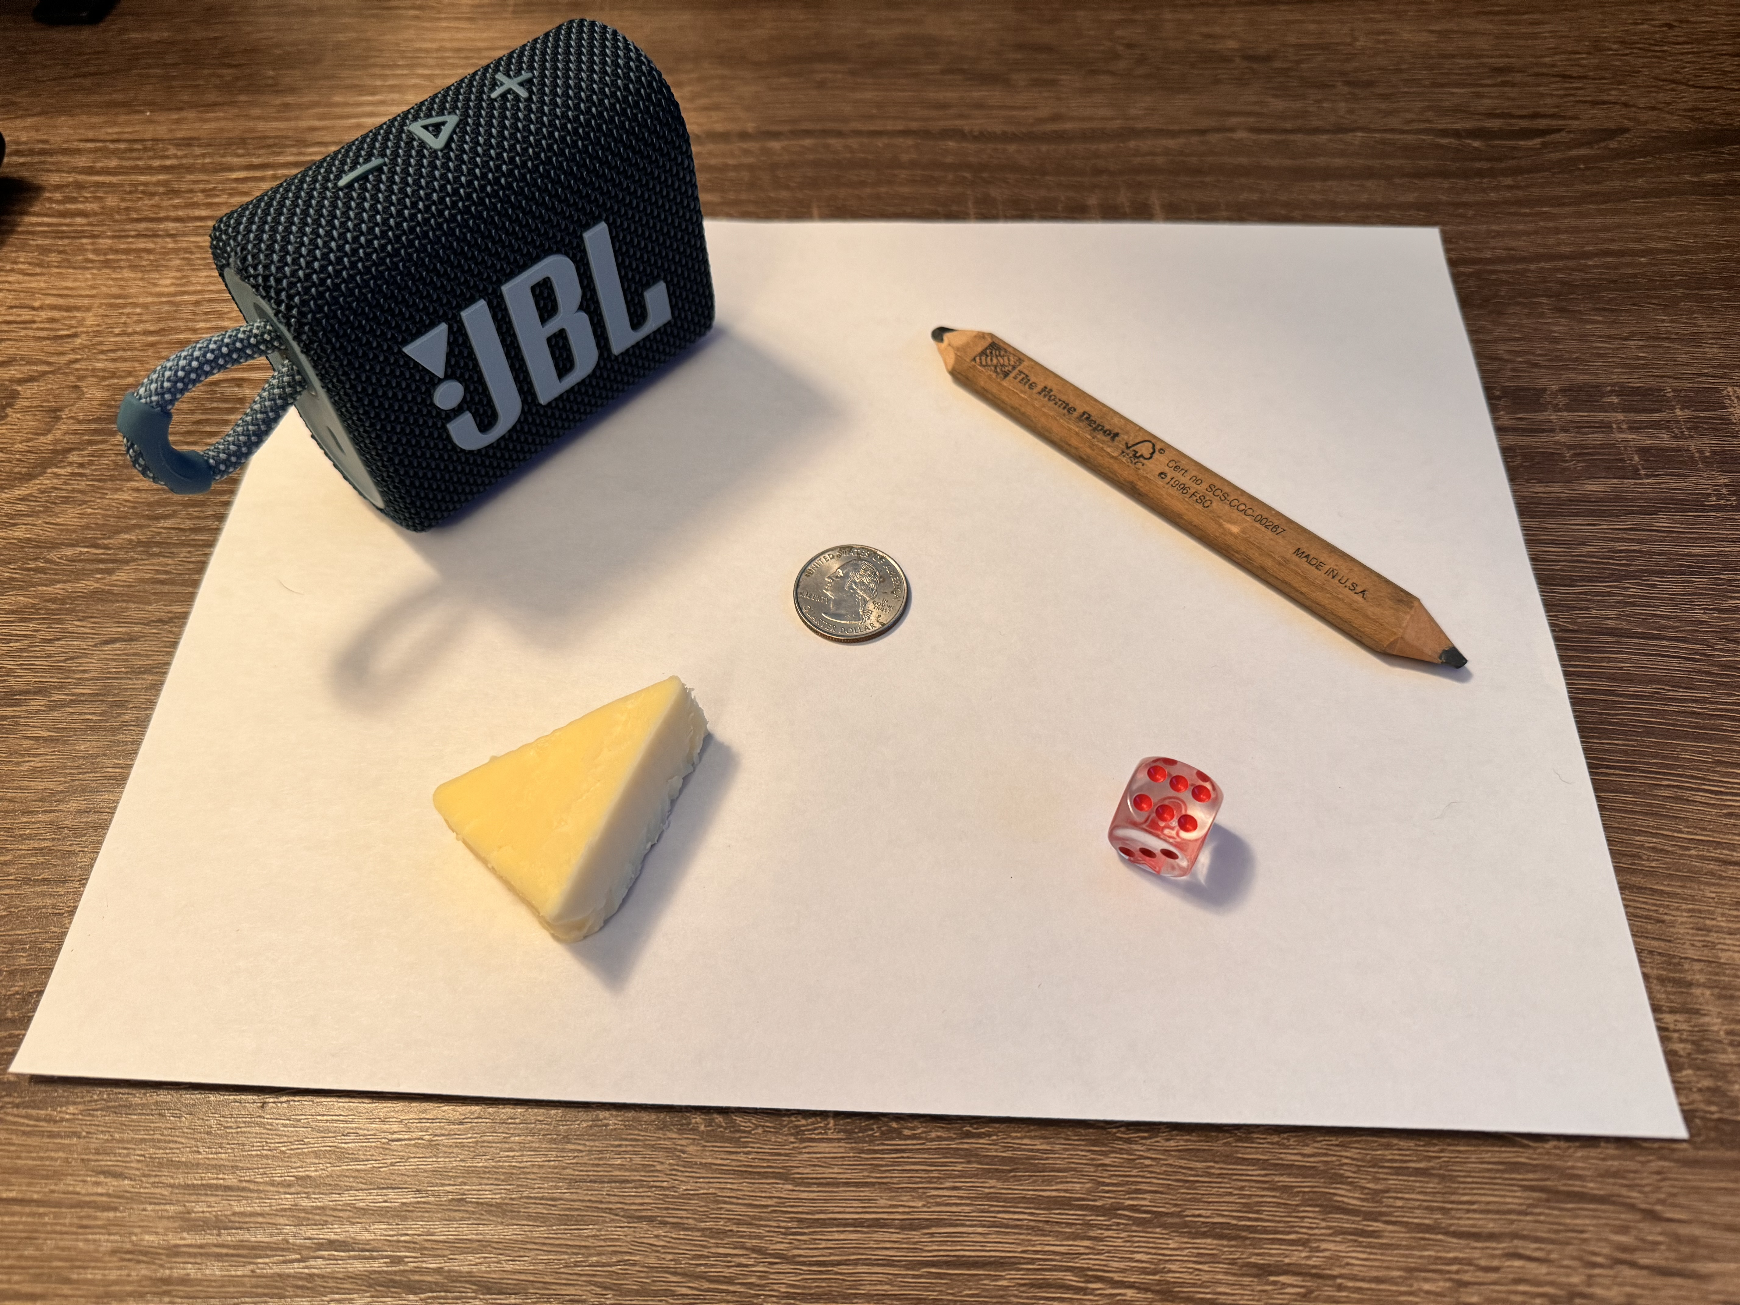

I plan to create a large plane to replicate the wooden desktop, which will serve as a background for the image. I will use a second plane on top of that to mimic the piece of paper on which the other objects will be placed. The remaining objects are a mini Bluetooth speaker, a quarter, a dice, a piece of cheese, and a carpenter’s pencil.

For the speaker, I am undecided on whether I will render it as an elongated cube or an elongated cylinder. I believe that the elongated cylinder will better represent the actual object. It will come down to how much time I have available to create the image. I will replicate the quarter with a very thin cylinder to give the appearance of a coin. The dice should be simple to create in the 3D model with a cube. For the piece of cheese, I plan to use a prism as the 3D representation. The carpenter’s pencil will be my complex object. Since it is more rectangular than a typical pencil, I plan to use an elongated box as the main body of the pencil, with a pyramid on each end to replicate the tips of the pencil.

Although the image I have chosen is not something from one of my favorite games, I still believe it will allow me to use an array of different 3D shapes. I did my best to find objects from around my home to best suit the needs of this project, and I am excited to work on it throughout the coming weeks and to see the final product.